**PROJECT DESCRIPTION**

**EXISTING METODOLOGY**

The proposed framework targets planning multipurpose self-governing farming automated vehicles that might be controlled through Internet/Bluetooth/Wi-Fi for watering the crops, removing weed, plowing, seeding, and irrigation systems. It uses one board computers (SBC's) called raspberry pi which isn't only compatible with the newest camera modules and sensors, but also possess exceptionally high-performance computational capabilities.The objectives of the proposed structure are to tunnel the earth contingent upon moistness level inside the earth, to wrinkle the seeds with teeth looks like structure at the top to show the most significant layer of soil down, to close the seeds and level the base normally and to deftly water framework system by sprinkling water with a guide inside the field**.** The traditional farming must be induced with the robotic mechanism and is extremely much required in precision farming. There would be remote-controlled robots’ occupation the agricultural fields soon see the herd. Due to the introduction of agricultural robots, there would be less labor required, and a person can plan and implement the operations of the farm by himself without relying on the availability of labor.

There are currently no previously designed robots in literature which fit our goal of destroying weeds while also maintaining safety of the desired plants roots. This is why since 2016 the Center for Biologically Inspired Robotics at CWRU has been working on a robot which will use a hexapod to move the base, allowing for traction in wet and dry environments. It will use a camera and LIDAR technology to differentiate from desired crops and weeds. It will then use an arm to destroy weeds above the surface, keeping the roots intact, while adding mulch, in the form of dead weeds, to the field. A hexapod design is desired to utilize legs for movement, as opposed to wheels or treads, which have been used for past similar projects. Preliminary estimates into required torque and power have been done.

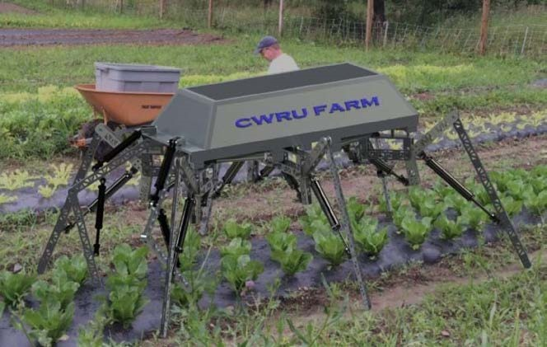

**FIG 1: DESIGN CONCEPT OF AG-BOT,A PLATFORM WHICH STAND AND MOVES WITH SIX HYDRAULICALLY ACTUATED LEGS.**

With these requirements the use of electric actuation has been ruled out, as it cannot supply the required torque within budget. Instead, the legs will be actuated by means of hydraulics. Previously, very little work was done in designing the arms of the robot. This important area of the robot, the weed destruction section, still had yet to be designed. The farm’s director is interested in a mechanism that acts as a weed whacker, chopping the weeds above the surface, keeping their bodies on the fields to act as a source of nutrition. This is against usual weeding practice, in which the roots are pulled, to remove the possibility of them growing back. It is believed that with the robot being able to make quick passes and to return to rows after a short period of time, its persistence in removing these weeds multiple times will cause the weeds to run out of energy and die over time

For this application, the use of an arm-like appendage is necessary as it will allow the tooling head to move quickly to its desired location, which could be a whole meter below the platform. Other mechanisms mentioned would not be able to traverse this distance while also being able to retract to avoid damaging the desired crops.

The proposed Ag-bot has the potential to respond brainwave signals with the help of EEG sensors and a Neuro Sky Headset. It can carry out tasks like ploughing fields, sowing seeds, cutting weeds and harvesting crops with the help of a unique image processing method which helps it to identify different types of vegetation with the help of a set of different preloaded images of different vegetation types.

Thus, this Ag-bot place a major role in the development of agricultural field. This Ag-bot enhances the following methods in agriculture like ploughing, sowing, irrigating, harvesting which is highly economical compared to the existing tractor. It is very user friendly to the farmers. Farmers can just think and operate this device easily**.** Bulky design of unit, can be overcome by modifications. Careful handling of electronic parts must be ensured. Setup is little heavier due to mild steel used; battery inefficient. Autonomous robotic weeding systems in precision farming have demonstrated their full potential to alleviate the current dependency on agrochemicals such as herbicides and pesticides, thus reducing environmental pollution and improving sustainability. In this paper, a nonoverlapping multicamera system is applied to provide flexibility for the weed control system in dealing with the indeterminate classification delays. The design, implementation, and testing of our proposed modular weed control unit with mechanical and chemical weeding tools are presented. A framework that performs naive Bayes filtering, 3D direct intra- and inter-camera visual tracking, and predictive control, while integrating state-of-the-art crop/weed detection algorithms, is developed to guide the tools to achieve high-precision weed removal. The experimental results show that our proposed fully operational weed control system is capable of performing selective mechanical as well as chemical in-row weeding with indeterminate detection delays in different terrain conditions and crop growth stages.

**3.1.2 DISADVANTAGE**

* Bulky design of unit, can be overcome by modifications.
* Careful handling of electronic parts must be ensured.
* Setup is little heavier due to mild steel used.
* Battery inefficient.